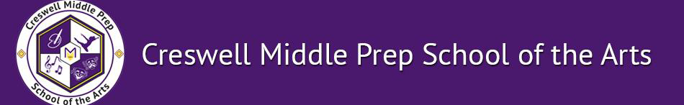

Dear Parents and Students,

Welcome to the wonderful world of sixth grade! I hope you had a restful summer break and are ready to begin this amazing school year. I am excited to meet you and begin our partnership to ensure success this school year.

My name is Mrs. Day and I am honored to be your Literacy Teacher here at Isaiah T. Creswell Middle Prep School of the Arts. This is my second year here at Creswell, and sixth year teaching. I am from Charlotte, North Carolina where I taught sixth grade, fifth grade, as well as first grade. My husband and I made the choice to move to Nashville so he could join the Teach for America Greater Nashville. We are strong believers in the power of education. I attended College at the University of North Carolina at Charlotte, where I earned a Bachelor's degree in Education and Psychology. We have a 21 month old son, Elliott who has stolen our hearts.

Parents, I strongly believe in open communication and working together to ensure success for your child. Every day, your child will be engaged in rigorous lessons that will push reading and writing skills. Our class will experience literacy in a number of ways, such as exploring different genres of Literature, analyzing nonfiction texts, applying reading strategies to passages, and determining / synthesizing the author's purpose. Parents, your child will need to read at home for at least 30 minutes a day. This is a crucial part of their reading development.

Students, we will be working hard this year. We will read and write everyday. I will push you to achieve above and beyond in order for you to be successful in academics, art and in life. I am an educator because I believe all children deserve to learn and can learn. I work for you, so please be prepared to learn day one.

Below is my contact information, my website will be updated frequently for daily questions and helpful websites. Please do not hesitate to contact me with questions or concerns.

Sydney Day
Email: sydney.day@MNPS.org
Phone: (704) 202-6413
Website: http://mrsday6thgrade.weebly.com
Again, I am beyond excited about the 2017-2018 school year, and beginning our partnership in order for your child to reach their fullest potential.

Sincerely,
Sydney Day
6th grade Literacy

