Name: _____________________________________
English 12
Gary Soto’s “Ode to Family Photographs”

Entrance Questions
Do you or your family take pictures of each other? When are you most likely to take family pictures? What is your favorite family picture?

Agree or Disagree
Statement | Agree | Disagree | Reason
It is important to capture the biggest moments in our life in pictures or we’ll forget them.

Pictures have the power to say more than words ever could.

Introducing Gary Soto
Gary Soto is known for a body of work that deals with the realities of growing up in Mexican-American communities; in poems, novels, short stories, plays and over a two dozen books for young people, Soto has recreated the world of the barrio, the urban, Spanish-speaking neighborhood where he was raised, bringing the sights, sounds and smells vividly to life.

Soto’s poetry focuses on everyday experiences while evoking the harsh forces that often shape life for Chicanos, including racism, poverty, and crime.

Soto says that “as a writer, my duty is not to make people perfect, particularly Mexican Americans. I’m not a cheerleader. I’m one who provides portraits of people in the rush of life.”

Soto has received high praise for his poetry—his collections have been finalists for the Pulitzer Prize and the National Book Award, and he has received a Nation/Discovery Award and the Levinson Award from Poetry.
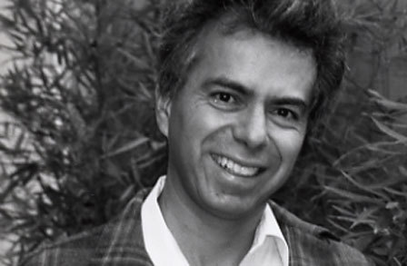
Ode to Family Photographs
by Gary Soto

Mama was never good at pictures.

This is a statue of a famous general who lost an arm,
And this is me with my head cut off.

This a trash can chained to a gate,
This is my father with his eyes half-closed.

This a photograph of my sister
And a giraffe looking over her shoulder.

This is our car's front bumper.
This is a bird with a pretzel in its beak.
This is my brother Pedro standing on one leg on a rock.
With a smear of chocolate on his face.

Mama sneezed when she looked
Behind the camera: the snapshots are blurry,
The angles dizzy as a spin on a merry-go-round.

But we had fun when Mama picked up the camera.
How can I tell?
Each of us laughing hard.
Can you see: I have candy in my mouth.

Questions
1. What does the speaker’s mother take pictures of? What does this tell us about her?

2. What is the author’s message to his reader? What are we supposed to learn from this poem?
What words or phrases help you know this?

3. What is the mood of this poem? What words or phrases help you to know this?

Write About It
Bring in several photographs of yourself and your family when you were younger, taken at places and events you remember fondly.

Visual Images Album
Image’s Name | What Happening | What This Tells Us

Using "Ode to Family Photographs" as a model, write a list poem based on these photos and your descriptions you’ve made in the above table.

Your list poem doesn't have to be humorous like Soto's. You might want to try more of a "documentary" list poem.

Patterns/ Repetitions in "Ode to Family Photographs"
Read the poem again and see if you notice any patterns, such as words and phrases that are repeated throughout the poem. Patterns need not occur in every line. List the words or phrases you see repeated here.

What do these repetitions tell us?

Final Thoughts
Do you think Soto remembers these moments with his family fondly? What evidence from the poem or your own life supports your answer?

